Specification Document

Project Name: P4
Client Name: Ray Greenhough
Team Number: 16
Document Version:
Date: 26/02/2026
Authors:

Name | Role | UoB Email | UoB Number
Tawfeeq Hussain | Leader | Thussa88@bradford.ac.uk | 24000557
Ibraheim Hussain | Secretary | Ihuss132@bradford.ac.uk | 24003673
Siraaj Ali | Team Member | Sali277@bradford.ac.uk | 24002882
Fayzaan Khan | Team Member | mfakhan@bradford.ac.uk | 24039463
Victor Nwagu | Team Member | nvnwagu@bradford.ac.uk | 23045806
Zain Ul Abedeen | Team Member | zabedeen@bradford.ac.uk | 24010906
Elysia Horder | Speaker | whorder@bradford.ac.uk | 24044847

  - Purpose of the Document
In this document, we hope to outline and illustrate the interaction between the system and the users, the methods of implementation, a list of requirements both functional and non-functional, and any LESP we have identified that should be recognised. This document will create a better understanding for stakeholders and support the developers during the construction of the system.
  - Project Overview
The project itself requires the development of a locally accessible multipage HTML website with appropriate styling choices and two supporting databases, with the underlying goal of showcasing all collected data and resources for local schools in the Bradford area. The two databases should allow the users to access and view the data which ranges from logbooks to staff records, in an efficient and organised manner.
  - Rationale for Topic Choice
With a variety of skills relevant for success within this project combined with our keen interest on working with HTML and database integration, we believe this project is the most suitable for maximising the potential of our skills and will allow us to deliver results and meet all requirements outlined by the client.
1.4 Team Expertise
Having previously completed our first-year module “Internet Technologies”, our team is equipped with a variety of relevant skills including website construction using HTML, CSS, JavaScript languages, database management using PHP and MySQL, and relevant documentation skills such as commenting, project management and LSEP identification. This skill set will enable success throughout the project as all members are able to contribute to all areas of the project which ensures different perspective can be recognised while developing the system.
1.5 Scope of the System
The system will be used for the primary purpose of storing and displaying data for the local schools, however the stakeholder has shared with the team the intention of using the system as a framework for creating additional websites in the future for further research into local history, therefore the baseline HTML structure should be designed in a reproducible way to ensure ease of replication and usage for further projects.
1.6 Related Documents
- Instruction Manual
- Gantt Chart & Calendar Plan
1.8 Assumptions and Risks
One potential issue that may occur is the loss of data when sending the completed version, however this has been mitigated by ensuring all completed files are uploaded to GitHub as a backup, and the final version will be stored and submitted via a secure USB to minimise data loss.
Another is version control, as there are multiple people working on different parts of the project we have had to utilise our GitHub workspace to ensue previous commits are accessible to ensure we can rewrite back to previous versions in case mistakes are made or data is lost.

2.1 System Context
The system is a web-based research portal designed for a local historian in Bradford. It serves as a centralized hub for managing and viewing historical data regarding staff and sources. The application integrates two SQL databases and a structured file system for historical images. It is built to be modular, allowing the historian to adapt the codebase for future projects.
The system will:
- Automatically open to Page 1 (Home Page) when launched.
- Provide navigation across 25 interconnected pages.
- Retrieve and display data from two SQL databases.
- Provide hyperlinks from database records to files stored in a structured Images folder.
- Allow reuse and adaptation of the design for future projects.

2.2 System Actors and Roles
Actor / Role | Description | Frequency of Use | Permissions / Responsibilities
Local historian(primary user) | Main user entering and viewing research data | Frequent | Can search databases, view all 25 pages, and modify code based on the manual
Researcher | Fellow researchers viewing the historian's work. | Occasionally | Browse historical sources, search staff records, and view linked images
SQL Database | The backend storage for Staffand Sources data. | Continuous | Provides searchable records to the browser interface.
Developer / Admin | Role responsible for initial setup and future adaptations | rare | Modify CSS/HTML, update database schema, and manage folder structures.
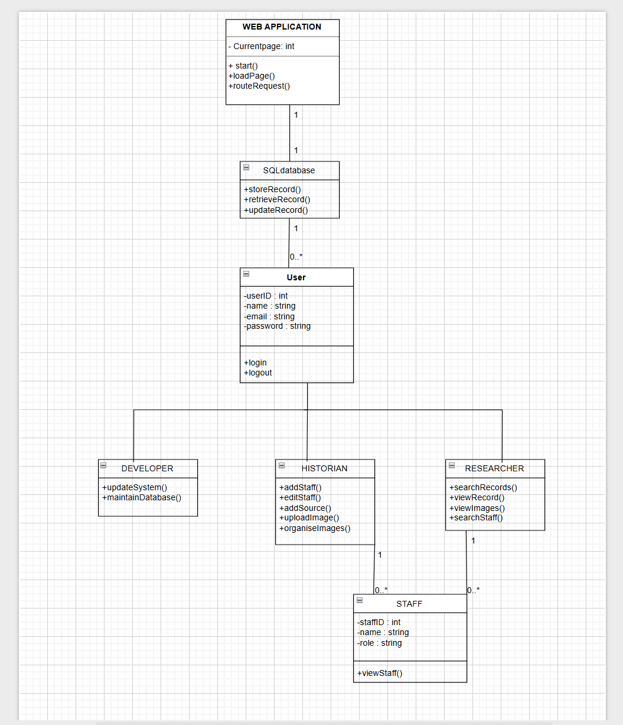
2.3 Dependencies and Impacts
System / Software | Type | Description | Risk/management
SQL Database Engine | Dependency | Necessary to store 'Staff' and 'Sources' data. | Risk: Data corruption. Mitigation: Regular backups of the SQL dump files.
Web Browser | Dependency | The interface where the 25 pages and autostart feature reside | Risk: Browser incompatibility. Mitigation: Use standard HTML5/CSS3 compliant code
File System | Dependency | The organized 'Images' folder (Books, Docs, etc.) that the app links to | Risk: Broken hyperlinks if folders are renamed. Mitigation: Strict naming conventions in the manual.
Legacy Research Files | impact | Existing physical/digital research notes. | Impact: Needs to be digitized and migrated into the new SQL format

4. Non-Functional Requirements
  - Performance Requirements

- The system should return search results from the SQL databases within 2 seconds under normal conditions.
Priority: High
Reason: The two searchable databases require fast response time to ensure effective searching.
- Hyperlinked PDF documents shall open within 5 seconds.
Priority: High
Reason: Large documents (some with several hundred pages) will be hyperlinked; therefore, users must be able to access them without long delays.
- Hyperlinked images of the appropriate images folder should load within 2 seconds.
Priority: Medium
Reason: The parent pages require the main image to link directly to the corresponding image. Ensuring fast image loading is essential to maintain a smooth user experience.

  - Security Requirements

- Direct access to database files and image document folder shall be restricted.
Priority: High
Reason: The system includes hyperlinked documents and structured folders, controlling the access prevents misuse.
- The system is expected to prevent unauthorized modification or deletion of database records.
Priority: High
Reason: The system stores staff and source information, therefore data integrity must be protected.
- The system shall validate all user input to ensure correctness and security before storing or processing the data.
Priority: High
Reason: The application is browser-based and is connected to SQL databases. Input validation is performed to prevent incorrect data.

  - Usability Requirements

- The system should automatically open to page 1 when launched.
Priority: High
Reason: The system brief explicitly requires to automatically start from page 1.
- Navigation buttons should change colour when hovering over them.
Priority: Medium
Reason: A visual hover effect should be performed to display clear visual interactivity and enhance usability.
- The system should operate correctly on modern web browsers.
Priority: High
Reason: The application must be accessible through a browser.
- The navigation across all 25 pages should be consistent and clearly labelled with comments and in line with page numbers.
Priority: High
Reason: The system includes 25 pages, so clear navigation is significant for usability.

  - Availability and Reliability Requirements

- The system should not crash when opening large documents from hyperlinks. Priority: High
Reason: Some linked pdf documents contain several hundred pages, which can lead to performance issues or system crashes.
- All hyperlinks should function correctly, with no broken or empty links.
Priority: High
Reason: The project requires extensive hyperlinking to documents and images, which must be implemented accurately to provide a intuitive and user-friendly experience.

  - Scalability Requirements

- The system should allow additional projects to be added in the future without a major redesign.
Priority: Medium
Reason: The client stated that other projects will be adapted to use this application.
- Both database structure shall support adding new records and tables when required.
Priority: Medium
Reason: The project requires further expansion of additional stored information, which the client will add using the instruction manual as a guide.

  - Maintainability Requirements

- All HTML and CSS code should be clearly commented with line numbers also included.
Priority: High
Reason: The industry client requires the code to be clearly annotated for adaption and line numbers must be implemented in the finished and finalised code.
- An instruction manual should be created to explain how to modify pages and hyperlinks.
Priority: High
Reason: The client requires full documentation for all potential future changes.

  - Non-functional / Acceptance Criteria
The following tests will confirm that non-functional requirements are met:
- Measure search response time using browser tools to confirm that It meets the stated time limit.
- Test opening of large PDF documents to ensure they open within the required number of seconds.
- Test the image loading speed by opening multiple linked images and confirming they display correctly and quickly.
- Manually check all the hyperlinks across the 25 pages to ensure there are no broken or incorrect links.
- For pages 5 and 6, attempt to enter invalid or incorrect data into the search criteria to confirm the system rejects improper input.
- Attempt to access restricted pages or database files directly through the browser search address bar to confirm access is blocked.
- Add, edit and delete database records to confirm data integrity is maintained.
- Insert many additional database records to confirm the system will still perform efficiently,
- Review all HTML and CSS code to confirm that it includes clear comments and line numbers.
- Follow the instruction manual to make a small modification (e.g. changing a hyperlink or updating HTML content) to ensure the system can be maintained and scaled upon easily.

5. Data and Reporting Requirements
5.1 Data Sources
The data sources for this project have been provided by Ray Greenhough and are historical records he has digitised and made available to us. These records are from: Chapel Green Board School, Thornton Lane Board School, Marshfield School, Chapel Green Church School and the Bradford School Board.
These sources take the form of logbooks, attendance and punishment records, meeting minutes, staff records, photograph albums and school plans.
5.2 Database Design
5.2.1 Staff Database
These sources take the form of logbooks, attendance and punishment records, meeting minutes, staff records, photograph albums and school plans.
The Staff table consists of an ID for each entry, acting as the primary key, several text fields for details about the staff provided by Ray Greenhough, alongside the year they were first employed stored as an integer and the year they left employment stored as a date.
These fields and data types are defined below:
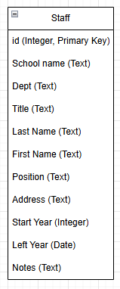
5.2.2 Sources Database
These sources take the form of logbooks, attendance and punishment records, meeting minutes, staff records, photograph albums and school plans.
The Sources table consists of an ID for each entry, acting as the primary key, and six text fields, five of which are details about the sources provided by Ray Greenhough. The last one, the hyperlink field stores hyperlinks to the HTML page upon which a particular source is stored.
These fields and data types are defined below:
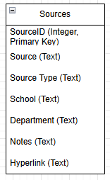
5.3 Data Structures
The data is stored within two tables inside an SQL database, saved as a local copy on the same device as the rest of the website so that it can be accessed. When data must be fetched from the database, it is obtained by generating an appropriate SQL query (depending on search parameters) and outputted to PHP as a list that can be read from and formatted into the HTML page for viewing.
5.4 Data Storage and Management
The database being utilised in this project is a MySQL database, which is accessible locally through either the programmed methods in the program itself or the PHPMyAdmin GUI. As the data input into the tables within this database is variable and does not have any formatting requirements or standards (i.e. email addresses or other such information), no validation rules are necessary besides ensuring the correct data type is provided.
Access control to the database itself is not present, but not necessary as it is being designed to run purely locally and as such does not present a need to require authorisation to access the database. This is because such authorisation is already present by virtue of having access to the local machine that the database is running on.

6.1 External System Interfaces
- SQL Database Servers
The system interacts with 2 external SQL databases:
- Staff Database – Contains records of staff who worked at the school.
- Sources Database – Contains books, documents, images, and logbook references
Protocols Used:
- SQL over TCP/IP (for MySQL/MariaDB servers)
- File-based SQL protocol (for SQLite if used locally)
Purpose of Interaction:
- Executing search queries
- Retrieving individual staff/source records
- Returning results to display on HTML pages
Data Exchanged:
- Inputs: user search terms, page requests
- Outputs: matching database rows (names, dates, descriptions, IDs, references)

- Local File System Interface (Images Folder)
The application relies on an external Images directory, subdivided into:
- Books/
- Documents/
- Images/
- Logbooks/
- (Additional categories as required by the project)
Protocols Used:
- HTTP file retrieval, through browser requests
- Relative URL links, e.g.:
- images/books/book_01.jpg
Purpose:
- Displaying scanned documents and images
- Navigating between pages using hyperlinks embedded in text or table entries

- Web Browser Interface
The browser serves as the rendering engine for the application.
Protocols Used:
- HTTP/HTTPS – for loading HTML/CSS files
- HTML5/CSS3 standards – for page rendering
- Default browser startup behaviour – set to open Page 1 automatically (index page)
Purpose:
- Render UI
- Handle hyperlink navigation
- Execute CSS styling
- Display images & tables

- Optional Server-Side Script Interface (If used)
If the implementation uses PHP or similar scripting:
Protocols Used:
- HTTP requests to server-side scripts
- Form submission protocols (GET/POST)
Purpose:
- Processing search requests
- Retrieving database results
- Handling input sanitisation

6.2 Error Handling and Exception Management
- Database Connection Errors
Possible Causes:
- Database server offline
- Incorrect credentials
- Corrupted or missing database file
Handling:
- Display a user-friendly message: “The system is unable to access the database. Please check your installation or contact support.”
- Log technical details in an error log (if supported)
- Stop further processing to avoid partial or incorrect data

- Search Query Errors
Possible Issues:
- Invalid characters in search fields
- Query returns no results
- Internal SQL syntax error (developer misconfiguration)
Handling:
- Validate user input (limit special characters)
- Display message such as: “No matching records were found.”
- Do not expose raw SQL error messages

- Missing or Broken Hyperlinks
Possible Causes:
- Image file moved, renamed, or deleted
- Incorrect directory structure
- Typo in relative URL
Handling:
- The browser will display a default “Image Not Found” placeholder
- Link text should remain visible for the user context
- The instruction manual must document the folder structure to prevent future errors

- Missing HTML Pages or Navigation Errors
Possible Causes:
- One of the 25 pages is missing
- Incorrect filename in the nav bar
- Deleted or corrupted HTML files
Handling:
- Redirect user to a generic error page (e.g., error.html)
- Provide navigation link back to Page 1 (index)
- Recommend validating project integrity before adaptation

- CSS or Header Modification Errors (Adaptation Failures)
Since the application must be adaptable for other projects, improper editing may break the layout.
Possible Issues:
- Deleted CSS classes
- Incorrect header replacement
- Misnumbered or removed annotations
Handling:
- Document safe edit zones clearly in the instruction manual
- Recommend testing after each change
- Maintain backups of original CSS and HTML files

- File System Errors
- Possible Issues:
- Images folder missing
- Incorrect directory names
- Insufficient permissions
Handling:
- Display a message in the browser, such as: “Required image directory not found.”
- Instruct the user to reinstall or repair the file structure

- Recovery Process
- Restart the browser → reloads Page 1 by default
- Restore missing folders/files from backup
- Reset headers or CSS files using guidance in the instruction manual
- Reconnect to the database and rerun the search

7. Timeline, Tasks and Deliverables

7.1 Gantt Chart
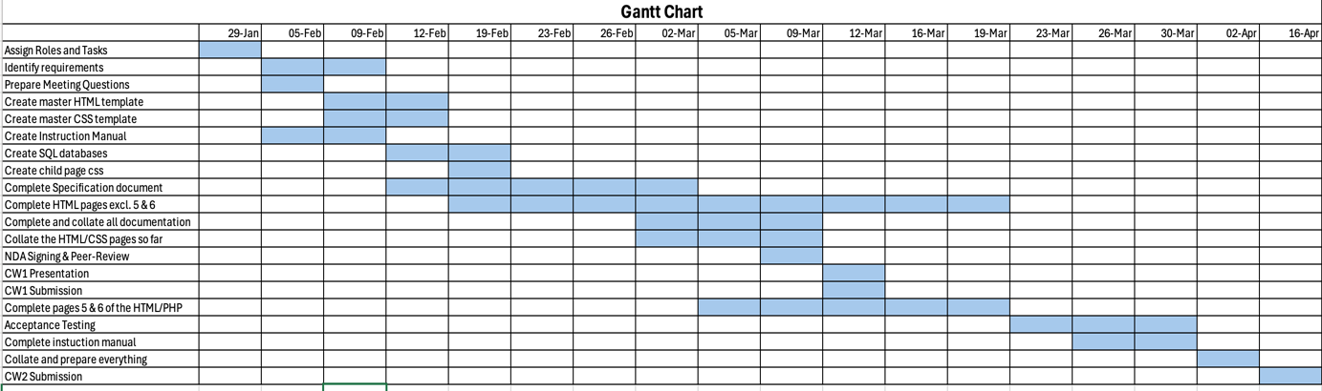

7.2 Task Allocation
Tawfeeq – Page
Ibraheim –
Siraaj –
Fayzaan –
Victor –
Elysia –
Zain -

7.3 Deliverables

8. Legal, social, Ethical, Professional, Risk and Economic Considerations (LSEPI)

8.1 Legal considerations (e.g. GDPR, data protection)
Although the web application will be run locally using XAMPP and will not be publicly deployed, it still stores information relating to staff members that may be identifiable. For this reason, relevant UK data protection legislation must still be followed, including the UK General Data Protection Regulation and the Data Protection Act 2018.
The overall legal risk for the application is significantly reduced because all data is supplied directly by the client. The system is locally hosted, does not collect new public data and does not allow external access or online modifications. As a result, concerns such as unlawful data collection or public data exposure are minimal.
However, certain legal responsibilities still apply. The data must only be used for the agreed academic and research purposes and must not be repurposed or distributed outside the scope of the project. Access to the databases and image folders must be restricted to authorised team members and all project files should be stored on password-protected machines. Maintaining data integrity is also important, meaning team members must not alter, fabricate or misrepresent the information provided by the client.
If required by the client, all team members must sign and comply with a Non-Disclosure Agreement (NDA) to formally confirm that the data will remain confidential and used only within the boundaries of the project.

8.2 Ethical considerations
Even though the project is run locally and all data is supplied by the client, there are still some ethical responsibilities to consider. The main concern is ensuring that the information is handled accurately and respectfully. Team members must not modify or misrepresent the data, and care should be taken when displaying sensitive material, such as personal staff information.
Social considerations are also relevant. The system could be used by multiple people within the team or by researchers in the future, so it is important to ensure that access is fair and that the information is presented clearly. The project team must ensure that all information is represented accurately. Responsible handling of data helps maintain trust between the client and the development team and supports good academic practice.
In addition, team members should respect the impact of digitising historical records. Providing electronic access to the records, reduces the need to handle fragile physical documents, helping preserve them for future research. Overall, the ethical and social considerations include using the data responsibly, ensuring accuracy and respecting the people and history represented in the records

8.3 Security and Privacy Risks / 8.5 Risk Analysis and Mitigation
Since the program runs locally using XAMPP and is not connected to the public internet, the overall security risk is quite low. The system cannot be accessed externally so risks such as DDoS attacks, man-in-the-middle attacks, ransomware or large-scale hacking attempts are very unlikely. Because the database is only available on local machines within the project team, exposure to serious cyber threats is minimal.
Main risks are practical rather than technical. One possible issue is the accidental deletion or modification of records. If a team member runs the wrong SQL query or edits the wrong entry, important data could be lost. There is also a small risk of database corruption if XAMPP is shut down incorrectly or if the computer crashes while the database is running.
Another concern is local unauthorised access. If team members leave their computers unlocked or share the project files outside the group, the client-provided data could be accessed by someone who is not involved in the project. While the data is being used for academic purposes, it should still be handled responsibly and kept within the agreed scope.
Backups of the database should be created so that data can be restored if something goes wrong. Team members should also ensure their computers are password protected and not left unattended while logged in. Project files and database copies should only be shared within the authorised group. By following these basic precautions, the system can remain secure and stable throughout development.

8.4 Professional Responsibilities
As developers of this university project, it is important to follow basic professional standards. This includes writing clear, well-organised and properly commented code, so that other team members or future users can understand and maintain it. All work should be documented properly, including how to set up the system and how to make necessary modifications.
Professional responsibility also involves handling client-provided data responsibly. Team members should ensure that databases and image folders are only accessed by authorised users and that data integrity is always maintained. To uphold these responsibilities team members must use password-protected machines and secure file storage, and client provided data must not be shared outside the group.
Finally, professionalism is about communication and teamwork. This includes agreeing on project rules, collaborating effectively, and being honest about any mistakes and struggles. Team members must behave responsibly, completing their share of work on time as well as attending all relevant team meetings. By following these practices, the team will demonstrate competence, accountability, and respect for the client and the projects academic requirements.

8.6 Economic Considerations
Since this web application is hosted locally, the financial costs in development are very minimal. XAMPP, which is used to host the website locally, is free to download and use. The database management system used within XAMPP, MySQL, is also open-source and free to use and because the system runs on a local server, there are no external web hosting costs or domain registration fees. As a result, the project can be developed and tested without any real expenses.
However, costs may arise if the project were to be scaled for real institutional deployment. In that case, the client would need to pay for professional server hosting, IT support, ongoing maintenance and potentially cybersecurity measures. There might also be costs associated with system updates, backups and long-term technical management.
At its current stage, the system is very cost-effective, but a full production version would likely require financial investment to ensure reliability and sustainability.

8.7 Environmental Considerations
Since the web application is hosted locally using XAMPP, its environmental impact is very low. The system runs on existing computers and does not require external data centres, large-scale cloud infrastructure or dedicated servers. This means that there is no additional energy consumption except for the powering computers and laptops that are used by the team members.
Because the project is digital, it also reduces the need for printed materials. Historical records can be viewed electronically rather than photocopied or physically handled, which helps reduce paper usage. All team resources are shared digitally via GitHub as opposed to printed documents to further help reduce paper usage.
If the system were to be deployed at an institutional level, environmental impact would increase slightly due to server hosting and increased power consumption. However, many web-hosting providers now use energy-efficient hardware and renewable energy sources, which can help minimise carbon footprint.
Overall, at its current local development stage, the environmental impact of the project is minimal, and the shift from physical to digital records offers small but positive sustainability benefits.

